Meet Director Notes Dallas ISD Championships! Harry S. Moss and Fair Oaks Park, Dallas Sat., February 21, 2026
Welcome back to one of our most anticipated events, the Dallas ISD Championships at our rescheduled site, Harry S. Moss Park in Dallas. Course Setter Stan Darnell has a full slate of courses with fun controls tucked away in our low-lying urban forest.
With its central location and lots of trails (as well as catching features in the form of roads), this is another venue that’s quite beginner friendly. So, bring some friends!
Some notes for you:
Registration: Online pre-registration is required. It’s easy and helps determine how many maps to print and how many runners to prepare for. We do print some extras, but not a lot- to guarantee you’re able to run the course you want you’ll need to register! Registration is open now. Be sure to download a waiver, fill it out and bring it with you – lines go faster that way! You can pay online via PayPal when you register, or by cash, check, CC or Zelle in person.
Event headquarters: The HQ is at the corner of Fair Oaks and Merriman Pkwy BUT the road is blocked off there so vehicles excluding buses can enter Merriman at Abrams Rd. Buses cannot turn onto Merriman- it is too narrow to turn around. Buses can park at Conrad HS and have students walk to HQ.
Registration is at Merriman and Fair Oaks, and the Start/Finish can be reached by walking on the paved bike/running path underneath Fair Oaks. Please don’t cross Fair Oaks at street level- it’s a busy road.
Parking: Cars may park along Merriman Parkway but enter from Abrams. Please don’t park in the tennis center down the street; they will get mad. Bus parking is in the Conrad HS parking lot a couple of hundred meters southwest from the HQ area, just off Fair Oaks Ave.
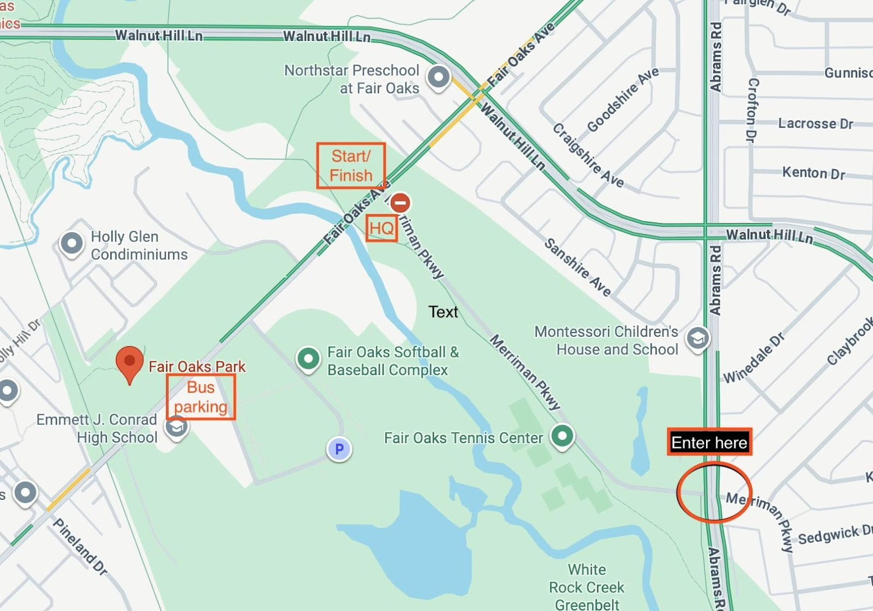
Watchouts: We share the park and its amenities with many other active people: Cyclists (road and mountain bike), runners, hikers and equestrians.
Be aware of cyclists on both the paved path and trails; move away from them while you’re standing and planning a route.
People on horseback always have the right of way: Move to the side of a trail and let them pass, and do not sneak up on them from behind, for everyone’s safety.
Vegetation: While it’s a bit early for poison ivy, you may run across some early growth. (Google it for an image.) If you’re on a course that leaves the trail, keep an eye out for this pesky plant. When you are finished, change clothes right away if you can and try not to touch your dirty ones. The oil can last for a long time and still give you a rash when you throw it in the laundry.
Finally, a big thank you to all of the volunteers who work tirelessly to bring about these events, including our assisting school, Bryan Adams High School!
Kristine Tisinger, 817-863-1555
P.S. Sign up for NTOA email to get event reminders and news.

