Texas Junior Orienteering Camp (TJOC)

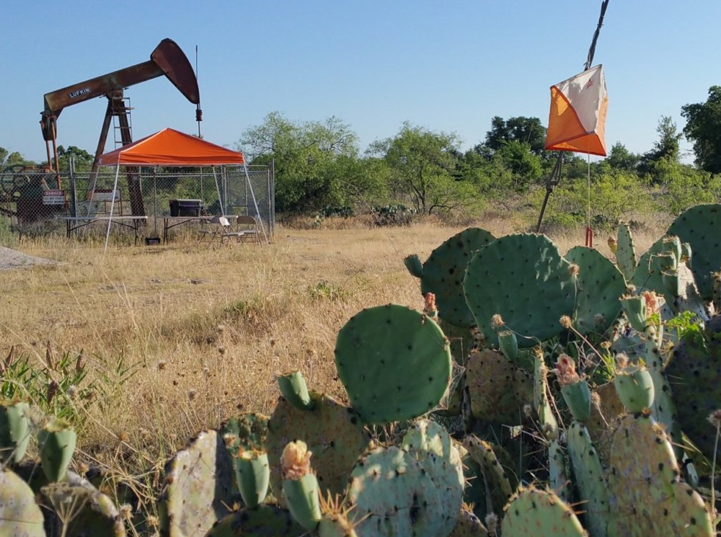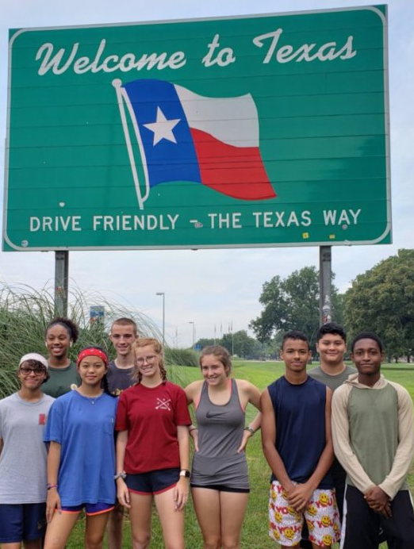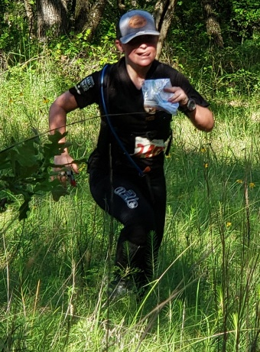

TJOC is a 6-day resident orienteering camp for 13-19 year-old junior orienteers who desire to take their skills to the next level. Learn from some of the best trainers in the U. S. Training is available at the Fast Start (Yellow), Intermediate (Orange), and Advanced (Green) levels. TJOC has been training junior level state & national champions for 20 years!

When and where is tjoc?
Sunday, June 4, 2023 through Friday, June 9, 2023
At the 2,500-acre Sid Richardson Scout Ranch, Lake Bridgeport, Texas.
Air-conditioned facilities including dorms, cabins, training rooms, & dining hall.

How much does tJOC cost?
$225 - junior orienteers & $100 - adult coach or chaperone
Includes all meals, lodging, facility fees, training materials, and air conditioning!

want to participate?
Ask your coach to contact the TJOC Camp Director, Ron Hojnowski @ hojnowski.ronald.snsi@navyjrotc.org or text/call (985) 788-8567.

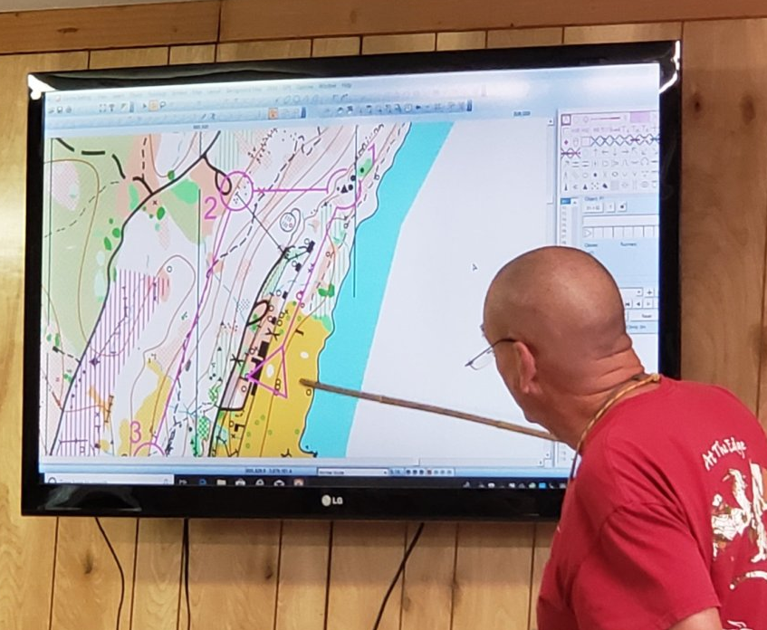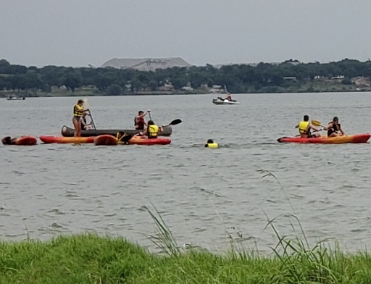

Ready for a TEXAS sized ORIENTEERING experience?
Visit: www.ntoa.com/tjoc

